Project Report

1. INTRODUCTION

1.1 Project Overview
Economic freedom plays a critical role in determining a country's prosperity, competitiveness, and the overall well-being of its citizens. However, while numerous datasets and reports exist, there is a gap in interactive and comparative tools that make this information accessible and actionable for diverse stakeholders.
This project aims to analyse and visualize the Index of Economic Freedom across multiple countries to provide insights into the relationship between economic policies and national prosperity. Using statistical analysis, data visualization techniques, and real-time filtering capabilities, the platform enables policymakers, researchers, investors, and the general public to explore key economic indicators in an intuitive and meaningful way.
The solution integrates data ingestion, processing, and visualization in a modular architecture, offering features like global freedom heatmaps, year-wise trends, top/bottom ranked countries, and correlation analysis with other socio-economic metrics like GDP and unemployment rates. This project bridges the gap between raw data and informed decision making through a transparent, scalable, and user-centric approach.

1.2 Purpose
The purpose of this project is to create an accessible, data-driven platform that enables the analysis and visualization of the Index of Economic Freedom across different countries and time periods. This initiative seeks to empower policymakers, researchers, and investors by providing them with actionable insights into how economic freedom influences prosperity, governance, and development. By transforming complex datasets into interactive dashboards and comparative tools, the project promotes informed decision-making, encourages transparency in economic policies, and supports academic and institutional research. Ultimately, the solution aspires to highlight global economic patterns and guide strategic reforms aimed at enhancing economic liberty and growth.

2. IDEATION PHASE

2.1 Problem Statement
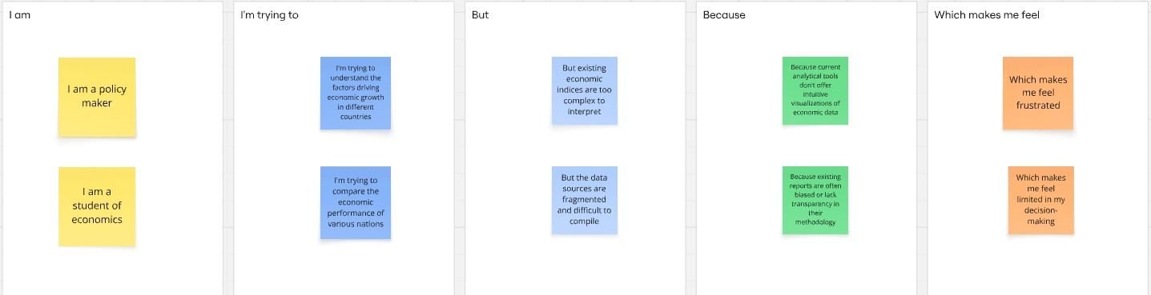

Problem  Statement  (PS) | I am  (Customer  ) | I’m trying to | But | Because | Which makes me feel
PS-1 | a  policymak  er | understand the drivers of economic  prosperity in different nations to formulate effective policies. | existing  economic  indices are often too complex, lack timely updates. | there's a need  for a  comprehensive,  easily digestible, and regularly updated index that integrates various dimensions of economic freedom. | frustrated and uncertain about the optimal policy choices.
PS-2 | an economic researcher | identify clear correlations between economic freedom and socioeconomic outcomes for academic analysis. | current data sources are  fragmented  ,  inconsistent , and difficult to  compare across different countries and time periods. | there isn't a standardized, reliable, and easily accessible  dataset that combines diverse indicators of economic freedom with  relevant outcome variables. | overwhelmed by data collection and analysis, and limited in drawing robust conclusions.

2.2 Empathy Map Canvas
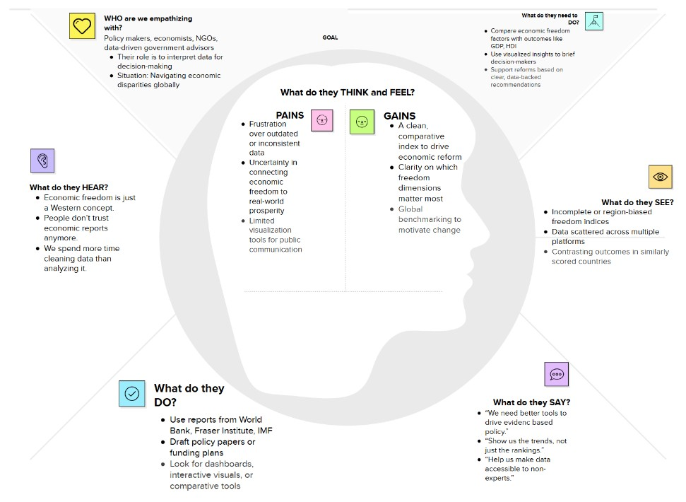

2.3 Brainstorming
Step-1: Team Gathering, Collaboration and Select the Problem Statement
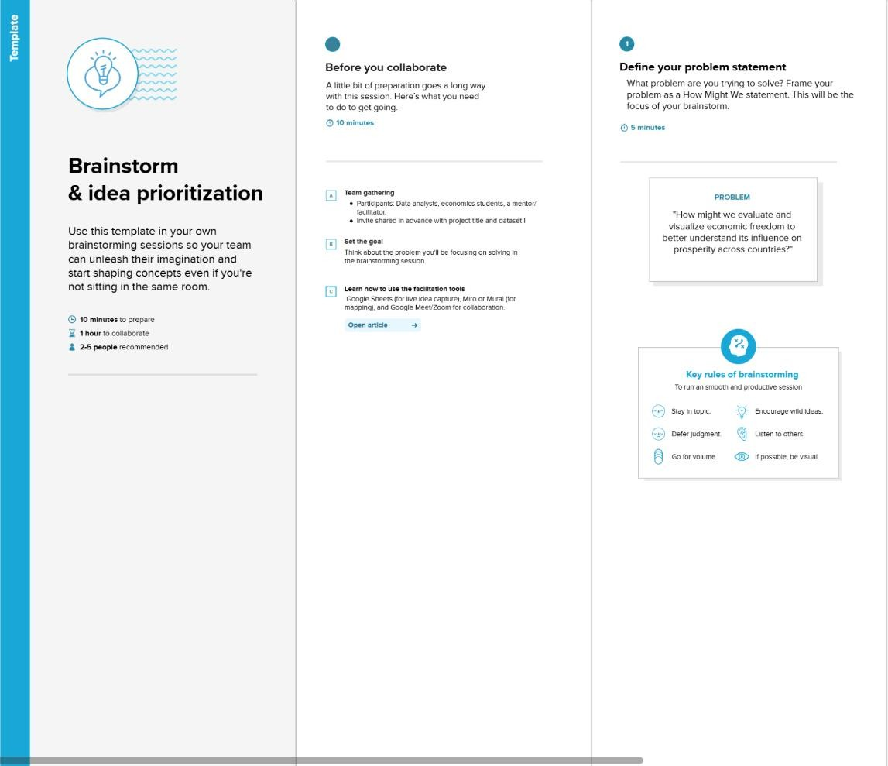
Step-2: Brainstorm, Idea Listing and Grouping
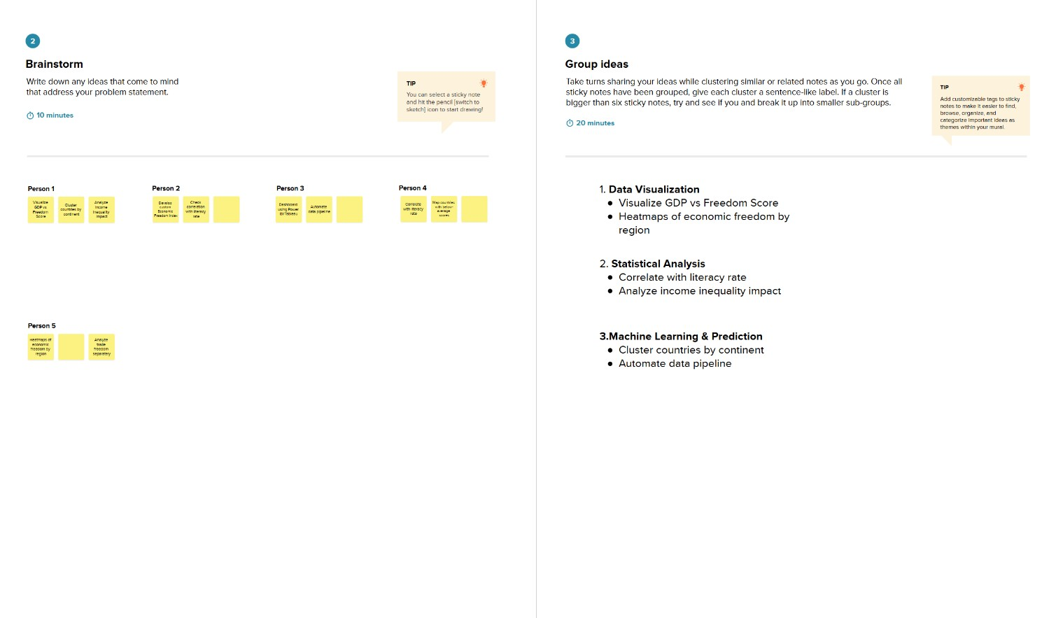
Step-3: Idea Prioritization
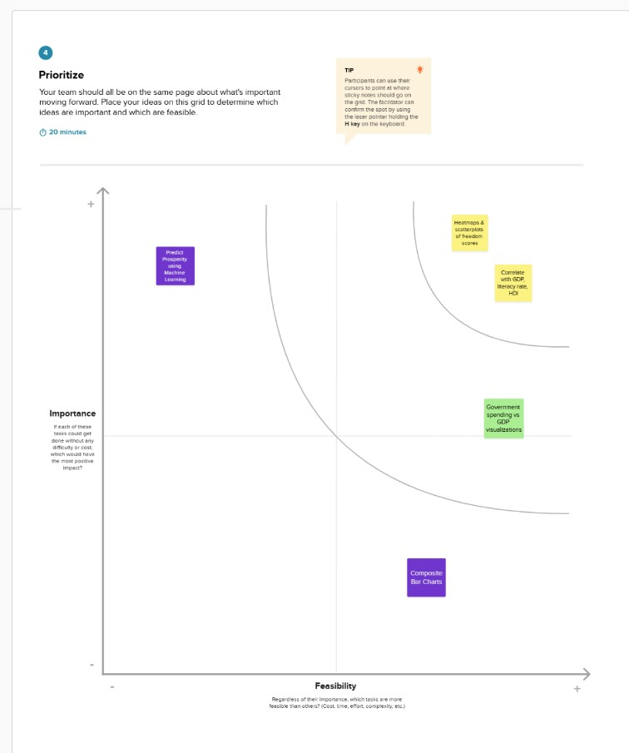

3. REQUIREMENT ANALYSIS

3.1 Customer Journey map
Stage | Actions | Thoughts | Touchpoints | Pain Points
Discovery | Learns about the platform via seminar, academic circles, or reports. | “Is there a tool that shows how economic freedom affects prosperity?” | University portals, policy newsletters, GitHub, search engines | Lack of accessible and reliable visualization tools
Access | Visits the platform and browses the landing page. | “Is this data recent? Can I trust the source?” | Web interface, data source links (e.g.,  Heritage  Foundation) | Trust in data, understanding source credibility
Interaction | Filters data by year/country, views heatmaps and rankings. | “I want to compare my country with others or across  years.” | Dashboard,  filtering tools, charts,  dropdown  selectors | Trust in data, understanding source credibility

3.2 Solution Requirement
Functional Requirements:
Following are the functional requirements of the proposed solution.
FR No. | Functional Requirement (Epic) | Sub Requirement (Story / Sub-Task)
FR-1 | User Registration | Registration through Form  Registration through Gmail  Registration through LinkedIn
FR-2 | User Confirmation | Confirmation via Email  Confirmation via OTP
FR-3 | Data Ingestion & Management | Upload Dataset (e.g., CSV, Excel, from external APIs)  Data Validation and Cleaning  Data Storage and Organization (e.g., database)
FR-4 | Economic Freedom Index  Calculation | Define and Configure Index Components  Apply Weighting Schemes (configurable by user/admin)  Calculate Composite Index Scores for countries/regions
FR-5 | Data Analysis & Visualization | Generate Interactive Charts (e.g., Bar, Line, Scatter, Bubble)  Create Geographic Visualizations (e.g., Choropleth Maps)  Provide Trend Analysis over Time  Enable Comparison between Countries/Regions  Display Correlation Matrices between indicators
FR-6 | Reporting & Export | Generate Customizable Reports (e.g., PDF, HTML)  Export Raw and Processed Data (e.g., CSV, Excel)  Export Visualizations (e.g., Image formats like PNG, JPEG)
FR-7 | User Authentication &  Authorization | User Login/Logout  Role-based Access Control (e.g., Admin, Analyst, Viewer)
FR-8 | Search & Filter Functionality | Search by Country Name, Year, Index Component  Filter Data by various criteria (e.g., region, income level)

Non-functional Requirements:
Following are the non-functional requirements of the proposed solution.
FR No. | Non-Functional Requirement | Description
NFR-1 | Usability | The system should have an intuitive and userfriendly interface, allowing users to easily navigate, interact with data, and interpret results without extensive training.
NFR-2 | Security | The system must protect sensitive user data (if any) and ensure the integrity and confidentiality of the economic data. This includes secure authentication, authorization, and protection against unauthorized access or data breaches.
NFR-3 | Reliability | The system should consistently perform its functions accurately and without significant errors. Data calculations, visualizations, and report generation should be reliable and repeatable.
NFR-4 | Performance | The system should respond quickly to user requests, especially during data processing, index calculation, and visualization generation, even with large datasets. Data loading and rendering times should be minimal.
NFR-5 | Availability | The system should be accessible to authorized users whenever needed, with minimal downtime. This includes considerations for server uptime, data accessibility, and disaster recovery.
NFR-6 | Scalability | The system should be able to handle an increasing amount of data (e.g., more countries, more years, new indicators), a growing number of concurrent users, and additional features without significant degradation in performance.
NFR-7 | Maintainability | The system's codebase and architecture should be well-documented, modular, and easy to modify or extend to accommodate future enhancements or bug fixes.
NFR-8 | Data Accuracy | The system must ensure the highest level of accuracy for all ingested data, calculations, and visualizations to reflect reliable economic insights.

3.3 Data Flow Diagram
User Stories
User Type | Function  al  Requirem  ent (Epic) | User  Story  Numb  er | User Story / Task | Acceptance  criteria | Priorit y | Releas  e
Policymaker | Data  Analysis & Visualizati on | USN-1 | As a Policymaker, I want to view a world map showing economic freedom scores by country, so that I can quickly identify regions with high or low economic prosperity and potential policy impact areas. | The map  correctly displays economic freedom scores, and I can identify regions visually. | High | Sprint-  1
Economic  Researcher | Data  Analysis & Visualizati on | USN-2 | As an Economic  Researcher, I want to filter economic data by specific years and countries, so that I can conduct in-depth analysis on historical trends and compare performance across different nations. | I can apply filters for years and countries, and the data displayed updates accordingly. | High | Sprint-  1
Investor | Data  Analysis & Visualizati on | USN-3 | As an Investor, I want to see the top 40 and least ranked countries based on their economic index, so that I can identify potential investment opportunities or risks in various markets. | The list of top and least ranked countries is accurate and  easily accessible. | High | Sprint-  1
User | Data  Ingestion  &  Managem  ent | USN-4 | As a User, I want to upload new economic datasets  (e.g., CSV, Excel), so that I can incorporate the latest information into the analysis and update the index. | I can successfully upload a dataset, and its data is visible in the system. | Mediu m | Sprint-  2
Economic  Researcher | Data  Analysis & Visualizati on | USN-5 | As an Economic  Researcher, I want to view correlations between  economic freedom and indicators like unemployment rate and GDP growth, so that I can understand the multifaceted impacts of economic policies. | The system generates a report with selected  criteria, and I can download it in my desired format (e.g., PDF). | High | Sprint-  2
User | Reporting  & Export | USN-6 | As a User, I want to export visualizations (e.g., charts, maps) as image files, so | I can export displayed visualizations | Mediu m | Sprint-  1
User Type | Function  al  Requirem  ent (Epic) | User  Story  Numb  er | User Story / Task | Acceptance  criteria | Priorit y | Releas  e
 |  |  | that I can easily include them in presentations or reports. | as image files (e.g., PNG, JPEG).
Administrat or | User  Managem  ent & Authorizati on | USN-7 | As an Administrator, I want to manage user accounts and roles, so that I can access levels to sensitive data and functionalities. | I can add, edit, and remove users, and assign. | High | Sprint-  1

4. PROJECT DESIGN

4.1 Problem Solution Fit

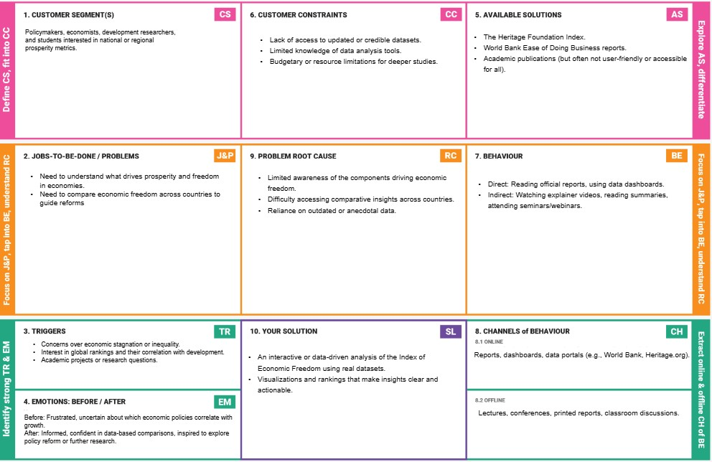

4.2 Proposed Solution
Proposed Solution Template:
Project team shall fill the following information in the proposed solution template
S.No. | Parameter | Description
1. | Problem Statement (Problem to be solved) | Despite the availability of macroeconomic data, policymakers and researchers lack a clear, accessible method to evaluate how economic freedom correlates with prosperity.
2. | Idea / Solution description | The project analyses the Economic Freedom Index using data visualization and comparative analysis tools. It offers clear dashboards, insights, and recommendations across countries
3. | Novelty / Uniqueness | While reports exist, this solution provides an interactive, comparative, and visually rich platform combining multiple data dimensions useful for academia and policy
4. | Social Impact / Customer Satisfaction | Informed citizens, better policy decisions, and transparency in economic governance. This tool helps identify reforms needed to enhance freedom and economic performance.
5. | Business Model (Revenue Model) | Can be offered as a freemium tool for students/researchers, with advanced insights and country reports available via subscription for institutions, think tanks, or NGOs.
6. | Scalability of the Solution | Can be extended to include regional/state-level indices, time-series trends, or integration with other indicators (e.g., Human Development Index, Corruption Perception Index).

4.3 Solution Architecture

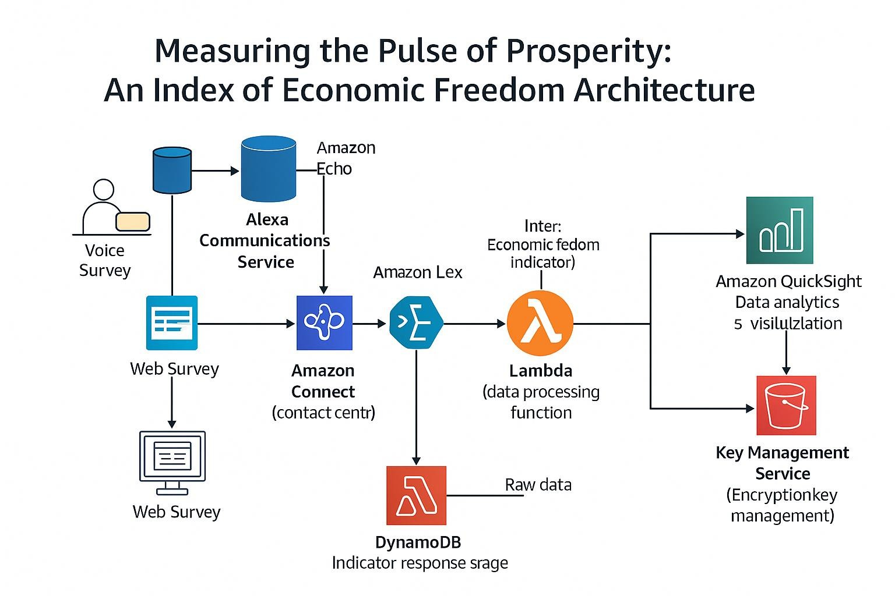

5. PROJECT PLANNING & SCHEDULING

5.1 Project Planning
Sprint | Functional  Requirement  (Epic) | User  Story  Number | User Story / Task | Story Points | Priority
Sprint-1 | Data Analysis  &  Visualization | USN-1 | As a Policymaker, I want to view a world map showing economic freedom scores by country, so that I can quickly identify regions with high or low economic prosperity and potential policy impact areas. | 2 | High
Sprint-1 | Data Analysis  &  Visualization | USN-2 | As an Economic Researcher, I want to filter economic data by specific years and countries, so that I can conduct in-depth analysis on historical trends and compare performance across different nations. | 2 | High
Sprint-1 | Data Analysis  &  Visualization | USN-3 | As an Investor, I want to see the top 40 and least ranked countries based on their economic index, so that I can identify potential investment opportunities or risks in various markets. | 2 | High
Sprint-2 | Data  Ingestion &  Management | USN-4 | As a User, I want to upload new economic datasets (e.g., CSV, Excel), so that I can incorporate the latest information into the analysis and update the index | 3 | Medium
Sprint-2 | Data Analysis  &  Visualization | USN-5 | As an Economic Researcher, I want to view correlations between economic freedom and indicators like unemployment rate and GDP growth, so that I can understand the multifaceted impacts of economic policies. | 4 | High
Sprint-3 | Reporting & Export | USN-6 | As a User, I want to export visualizations (e.g., charts, maps) as image files, so that I can easily include them in presentations or reports. | 4 | Medium
Sprint-3 | User  Management &  Authorization | USN-7 | As an Administrator, I want to manage user accounts and roles, so that I can access levels to sensitive data and functionalities. | 3 | High

Project Tracker, Velocity & Burndown Chart:
Sprint | Total Story Points | Duration | Sprint Start Date | Sprint End Date (Planned) | Story Points  Completed  (as on  Planned End  Date) | Sprint Release Date (Actual)
Sprint-1 | 6 | 5 Days | 16 June 2025 | 21June 2025 | 6 | 21 June 2025
Sprint-2 | 7 | 5 Days | 21June 2025 | 25 June 2025 | 7 | 25 June 2025
Sprint-3 | 7 | 5 Days | 25 June 2025 | 30 June 2025

Velocity:
Imagine we have a 10-day sprint duration, and the velocity of the team is 20 (points per sprint). Let’s calculate the team’s average velocity (AV) per iteration unit (story points per day)
AV = sprint duration/velocity =15/10=1.5

Burndown Chart:
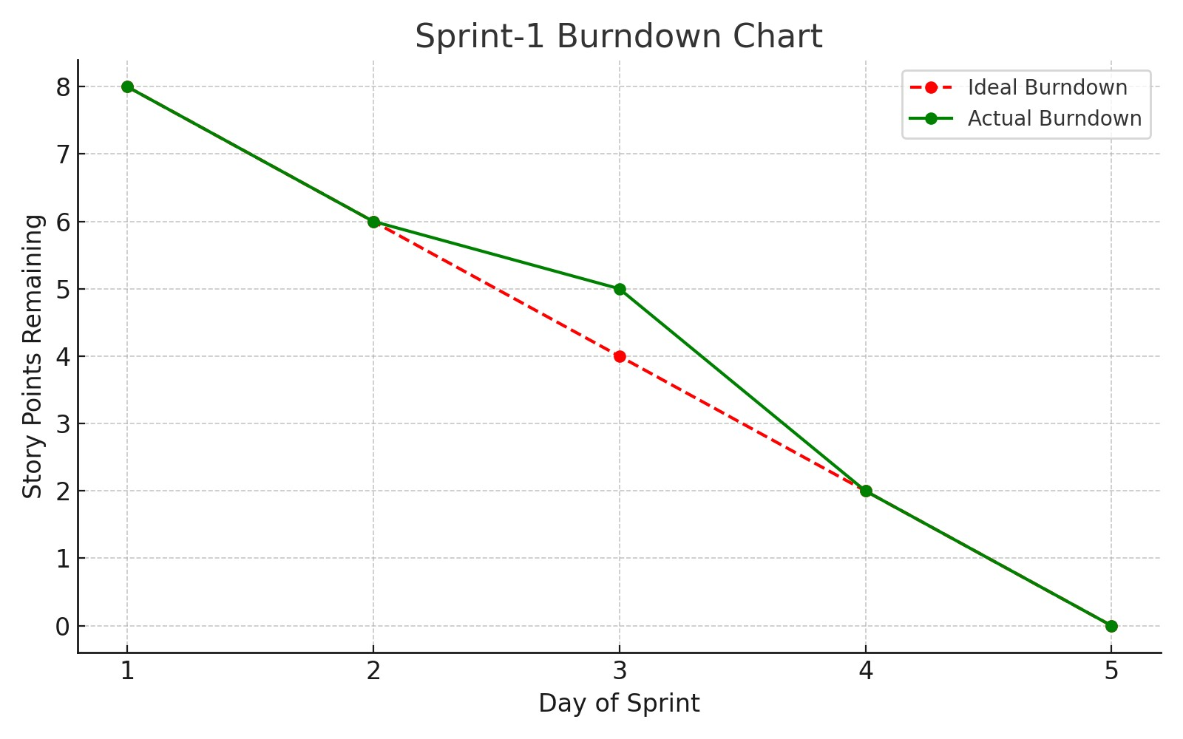
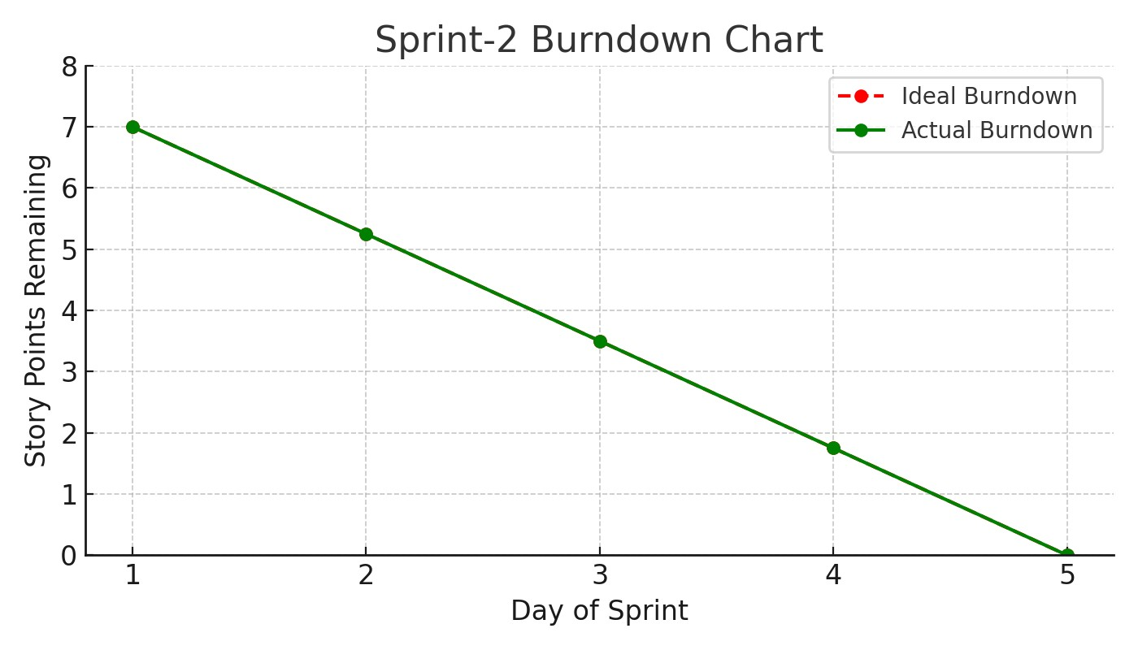

6. FUNCTIONAL AND PERFORMANCE TESTING

6.1 Performance Testing
Model Performance Testing:
Project team shall fill the following information in model performance testing template.
S.No. | Parameter | Screenshot / Values
1. | Data Rendered | The dashboard renders comprehensive country-level economic data including:  - Economic Score/Index  - Country ID and Country Name  - 5-Year GDP Growth Rate  - Business Freedom, Corporate Tax Rate (%), FDI Inflow  (Millions), Financial Freedom, Fiscal Health, GDP (Billions),  GDP Growth Rate (%), GDP per Capita (PPP), Government  Integrity, Government Expenditure (%) of GDP, Government Spending, Income Tax Rate (%), Inflation (%), Index of Population, Unemployment (%).  -The data appears to cover multiple years, showing trends and comparisons across a wide range of countries

2. | Data Preprocessing | Preprocessing likely involved:  - Data Cleaning: Handling missing values, correcting inconsistencies, and standardizing country names.  - Data Transformation: Aggregating data to specific years or regions, potentially calculating the composite Economic Freedom Index from its constituent components.  - Geographic Data Preparation: Ensuring country names are recognized by Tableau for mapping.  - Feature Engineering: Creating calculated fields such as "5 Year GDP Growth Rate" or specific "Economic Score" components if not directly present in the raw data.
3. | Utilization of Filters | The dashboard extensively uses filters and interactive elements:  - Country Name Filter: Allows users to select specific countries for focused analysis.  - Measures Filter: To select different economic indicators (e.g., Inflation, Unemployment, GDP) for visualization and correlation.  - Year Slider/Filter: To change the year for which the data is displayed on the map and other charts.  - Interactive Map Selection: Clicking on countries on the map appears to filter other related views
4. | Calculation fields Used | Based on the metrics and visualizations, the following calculated fields are likely used:  - Economic Score/Index: A composite score derived from various sub-indicators of economic freedom.  - 5 Year GDP Growth Rate: Likely a calculation based on GDP values over a five-year period.  - Rankings: Calculated fields to determine and display the "Top 40 countries rank of Economy" and "Least ranked countries of economic index."  - Region Groupings: Possibly a calculated field to group countries into broader regions for high-level analysis.
5. | Dashboard design | No of Visualizations / Graphs –  The primary dashboard ("Dashboard 1" / "Global Rankings & Financial Freedom Impact Dashboard") contains at least 5 distinct visualizations/sections
- Choropleth Map (e.g., "Visualizing Economic Freedom and Instability Around the World")
- Correlation Chart (e.g., "Correlation of Countries Based on Inflation & Unemployment")
- Horizontal Bar Chart (e.g., "Index of Population")
- "Insights Overview" Text Box
- "Top 40 Countries rank of Economy" bar/map chart
-"Countries Less Than 25 of Economy Index" (potentially a tree map or similar chart)
6 | Story Design | No of Visualizations / Graphs –  The "Story" section ("Journey Through the 2002 Global Economy") explicitly shows 5 story points/pages, each potentially containing one or more visualizations:  - Story Point 1: World Map of Economic Score.  - Story Point 2: Top 40 Countries Rank.  - Story Point 3: Least Ranked Countries.  - Story Point 4: Correlation of Countries Based on Inflation & Unemployment.  - Story Point 5: Index of Population.  - Story Point 6: Financial Freedom of Countries.  - Story Point 7: Index of 5 yrs GDP Rate.

7. RESULTS

7.1 Output Screenshots

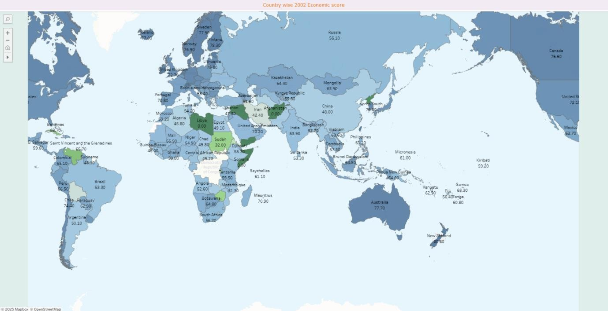

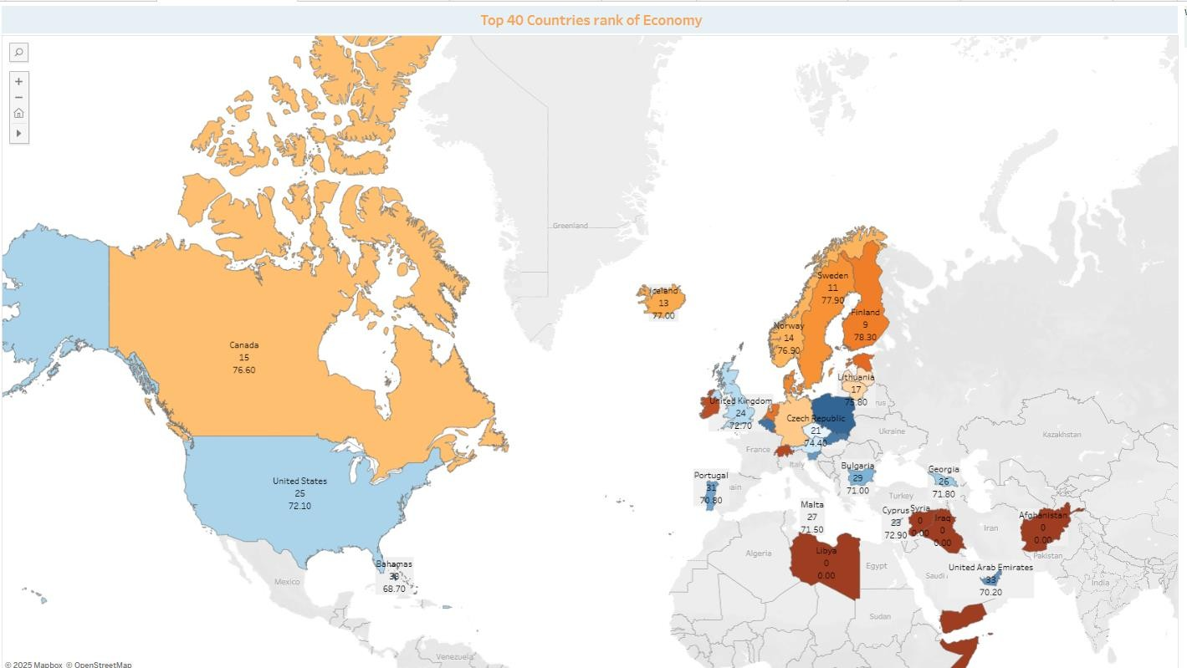

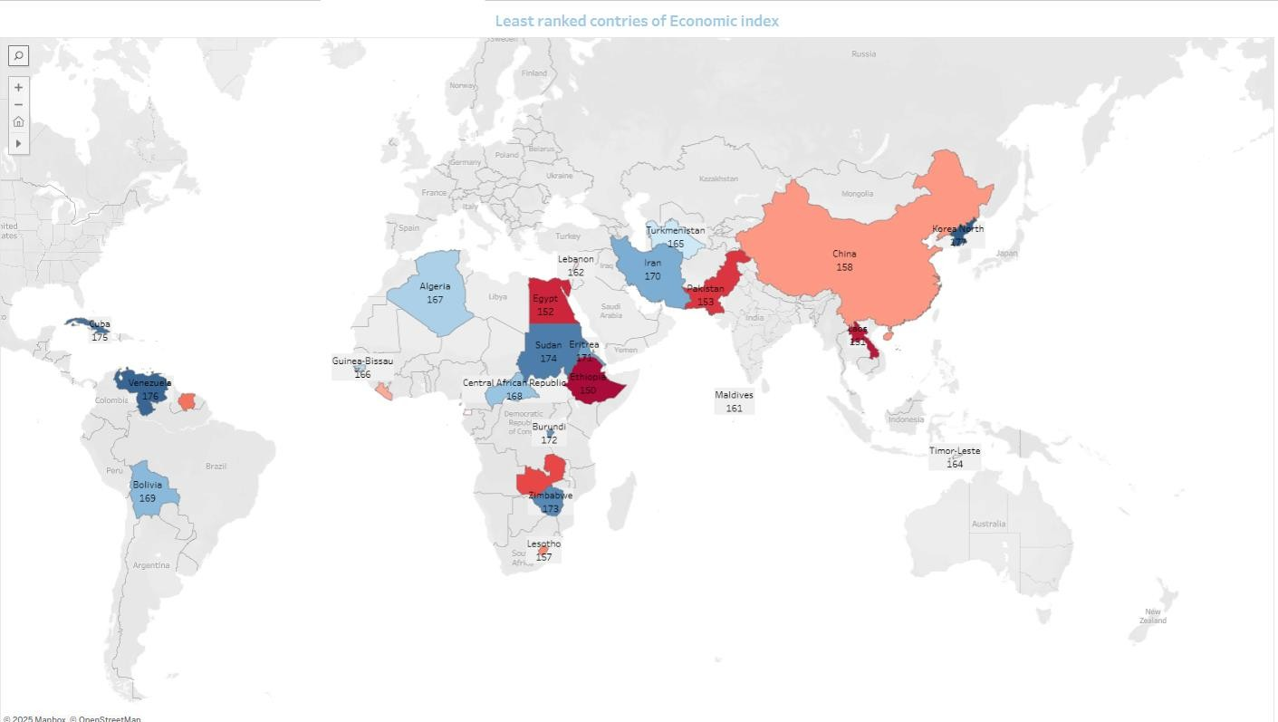

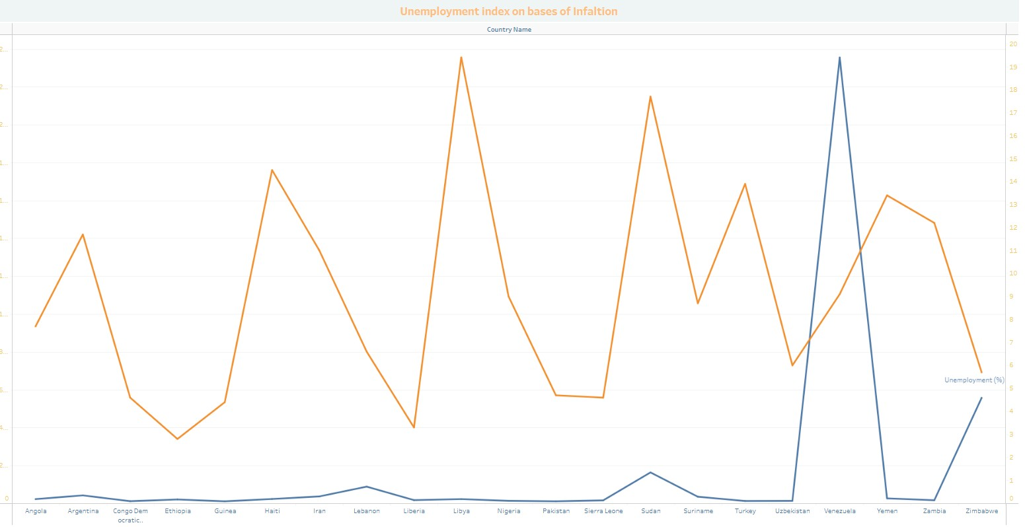

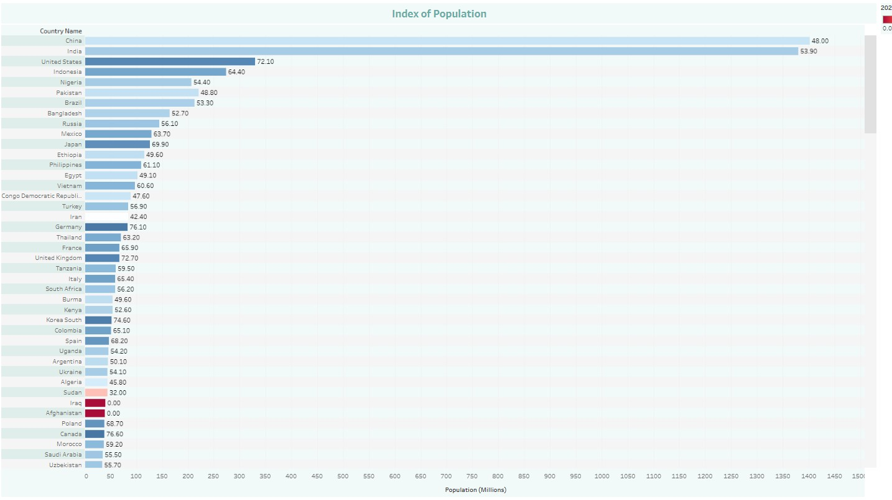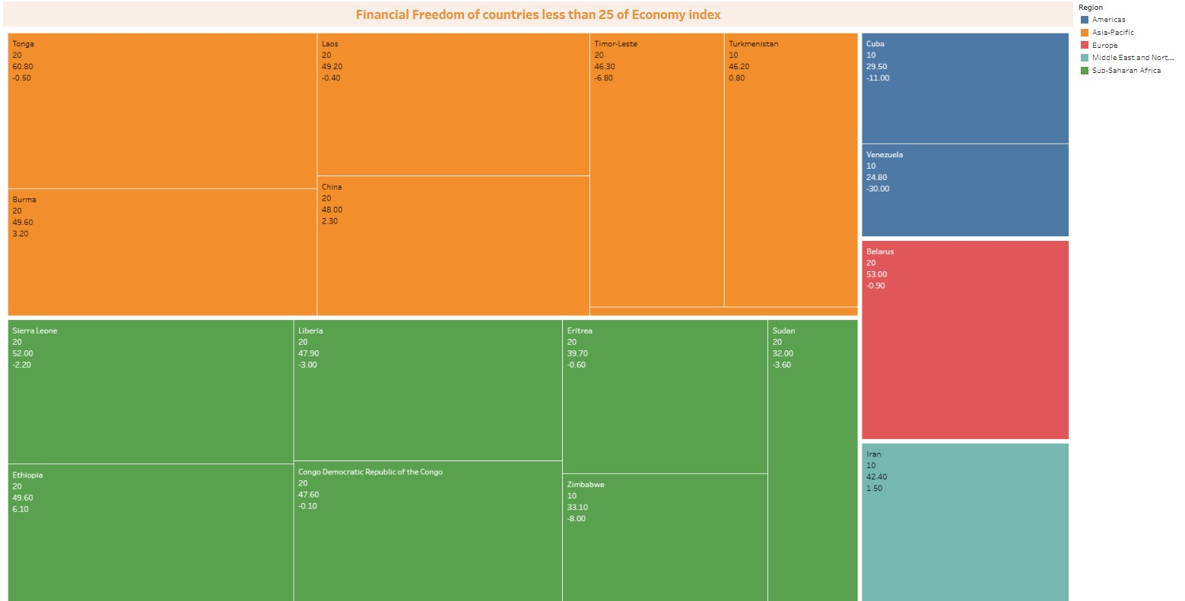

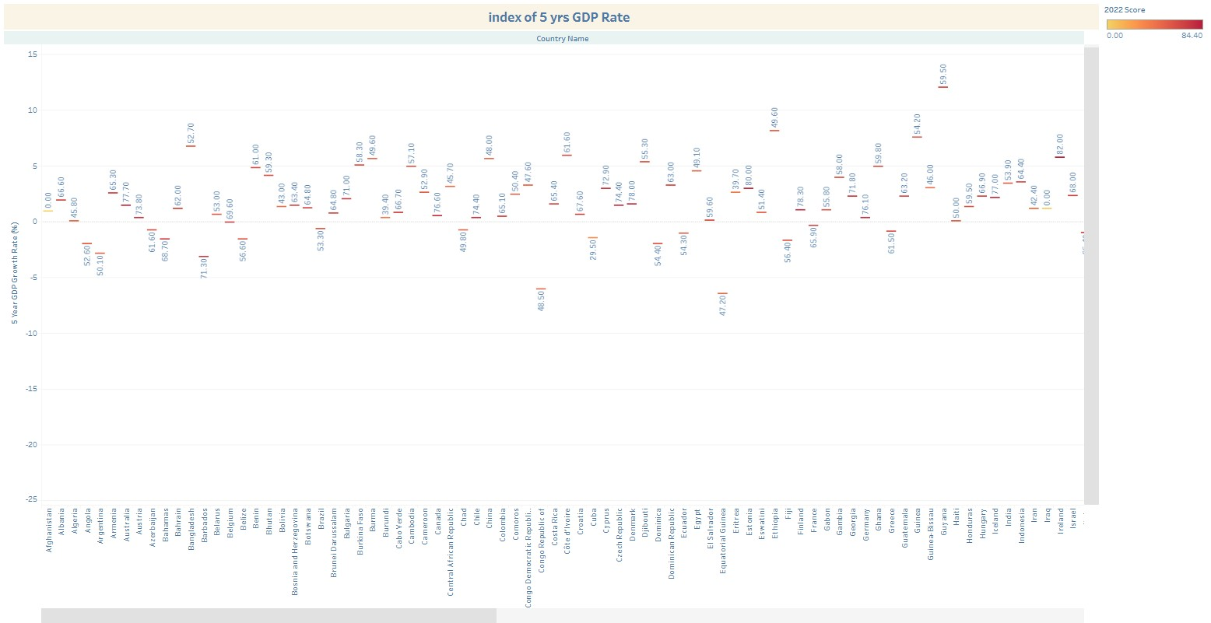

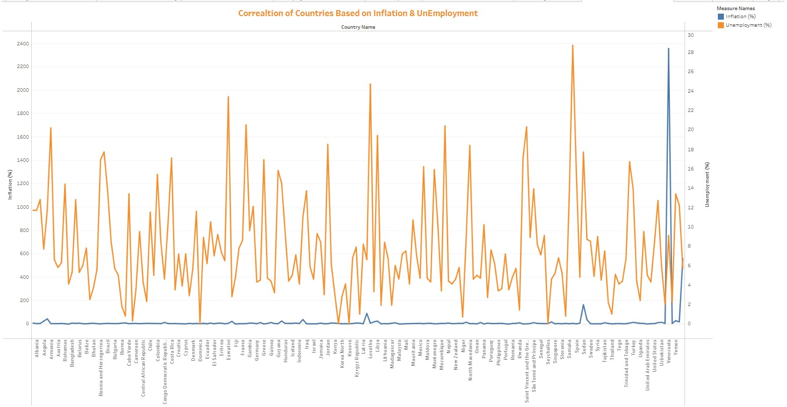

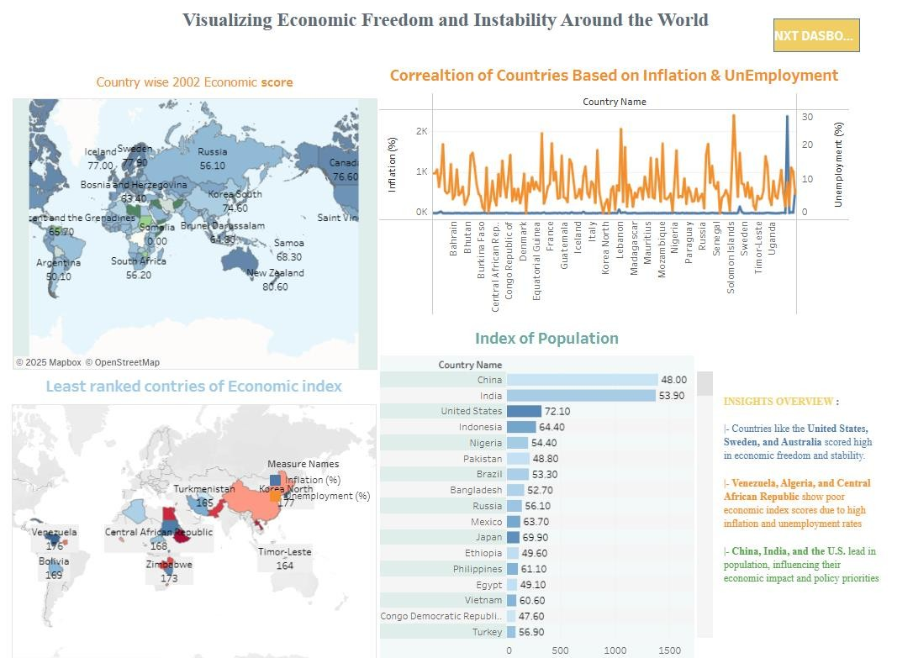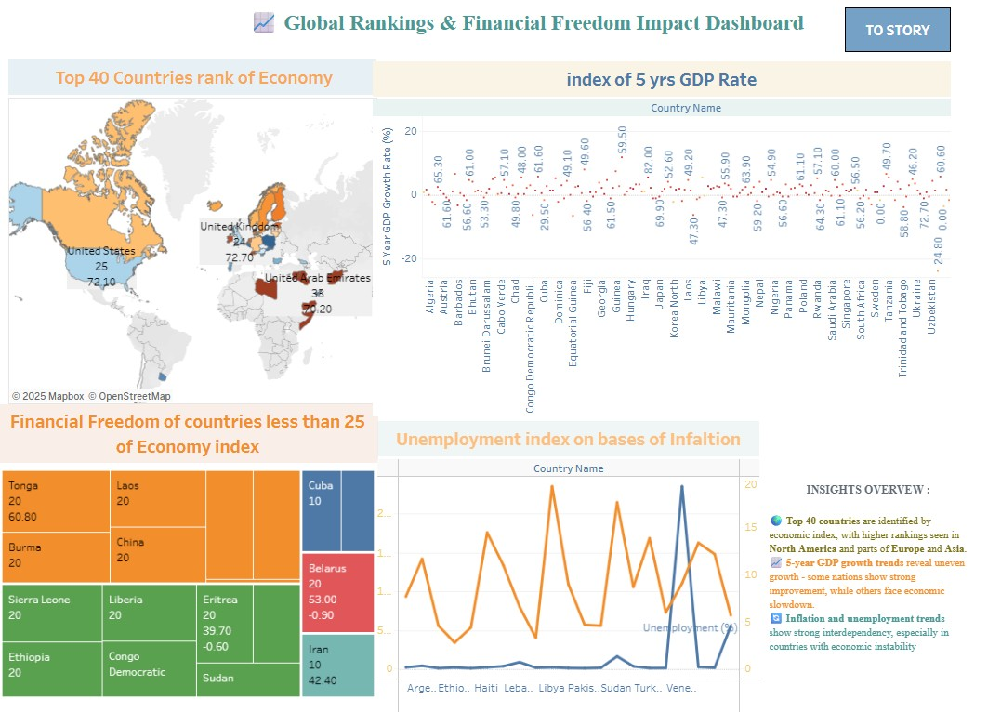

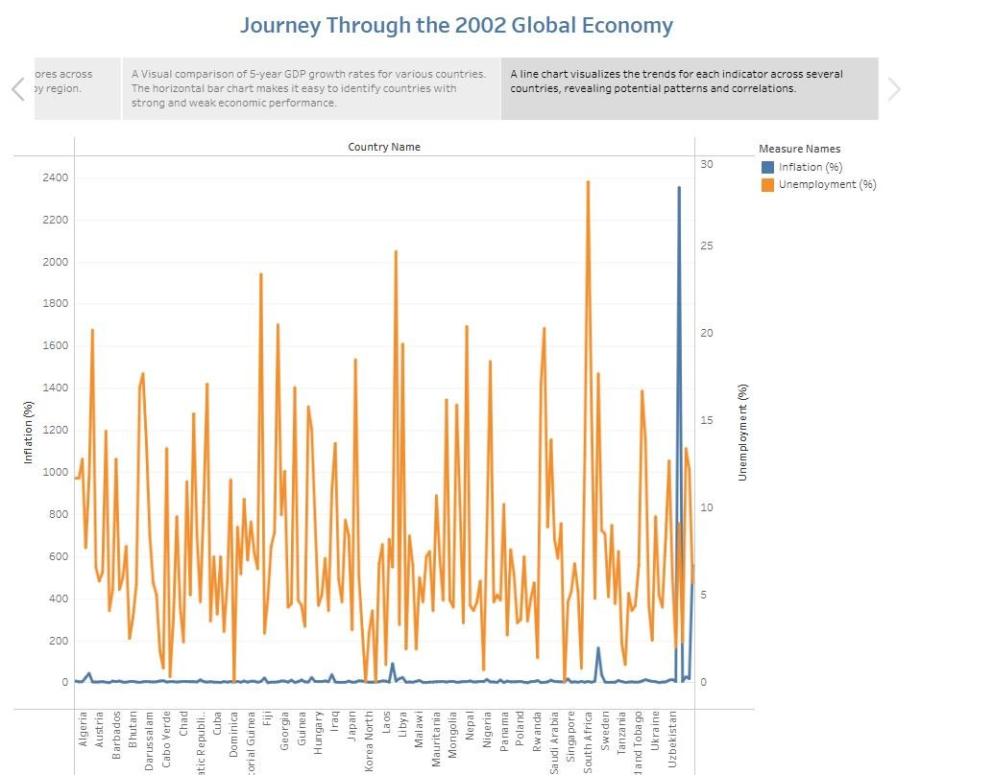

8. ADVANTAGES & DISADVANTAGES

Advantages
- Data-Driven Insights
Empowers users to make informed decisions using real-time, evidence-based economic indicators.
- Interactive Visualization
User-friendly dashboards allow for filtering by year, country, and economic subindices, making analysis accessible to non-technical users.
- Multi-Stakeholder Utility
Useful to policymakers, researchers, investors, and students alike, each gaining insights specific to their objectives.
- Customizable & Scalable
The modular architecture allows easy integration of new datasets, indicators, or visualization layers.
- Open-Source & Cost-Efficient
Built using open-source tools like Python, Plotly, and Streamlit, reducing development and deployment costs.

Disadvantages
- Data Source Dependency
The analysis is limited to the scope and accuracy of available datasets like those from the Heritage Foundation or World Bank.
- Limited Real-Time Updates
Economic freedom indices are not updated frequently, which may affect relevance for real-time policy decisions.
- Technical Barriers for Non-Digital Users
Despite being user-friendly, some stakeholders without digital literacy may find the platform less accessible.
- Infrastructure Limitations
Hosting and processing large datasets or high user traffic could require scaling the cloud infrastructure, leading to additional costs.

9. CONCLUSION:
The project “Measuring the Pulse of Prosperity: An Index of Economic Freedom Analysis” successfully demonstrates the power of data analytics and visualization in transforming static economic data into meaningful, actionable insights. By leveraging open-source tools and interactive dashboards, the platform bridges the gap between complex economic indicators and userfriendly interpretation.
This solution empowers policymakers, researchers, and investors to explore global economic trends, identify policy gaps, and make evidence-based decisions. The integration of filtering, correlation analysis, and exportable visualizations enhances the usability and adaptability of the system across various domains.
Through this initiative, we’ve laid a scalable foundation for deeper exploration of how economic freedom shapes prosperity—enabling smarter governance, more informed investment, and a clearer understanding of global economic landscapes.

10. FUTURE SCOPE
- Integration of Real-Time Economic Indicators
Future versions of the platform can incorporate APIs for real-time data (e.g., GDP updates, inflation, employment) to enhance the system’s relevance for ongoing policy and market analysis.
- Expanded Dataset Coverage
The project can be extended to include regional/state-level data, enabling microeconomic analysis within countries and more localized policymaking insights.
- Machine Learning-Based Forecasting
Implementing predictive models can help forecast future economic freedom scores or prosperity indicators based on historical patterns and current inputs.
- User Personalization and Notifications
Future iterations could allow user accounts with saved filters, email alerts for new reports, or policy shifts relevant to selected countries.

11. APPENDIX
Dataset Link:
https://drive.google.com/file/d/1YCdJwG9URzwggHI7vXpJ5Dv1FvAynbnl/view?usp=drive_link
GitHub & Project Demo Link:
Project Demo Link:
https://drive.google.com/file/d/1pcmV6YmhDYKApknHfi8nSextZtdyUmQc/view?usp=drive_link
GitHub Link:
srisanth1234/Measuring-the-Pulse-of-Prosperity-An-Index-of-Economic-Freedom-Analysis

